Diagnostic 586220 Harness - Keyboard Dongle Extended Rev. 0

Testing

The Rev. 0 prototype was not functional and required a modification to work properly.

R2 had to be changed from 10k to 1k and an additional resistor (R4) had to be inserted between the pull up and the base of Q1.

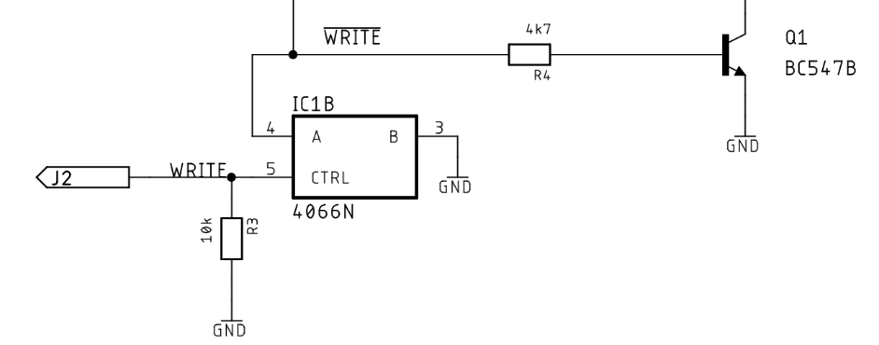

Figure 1: Required modification

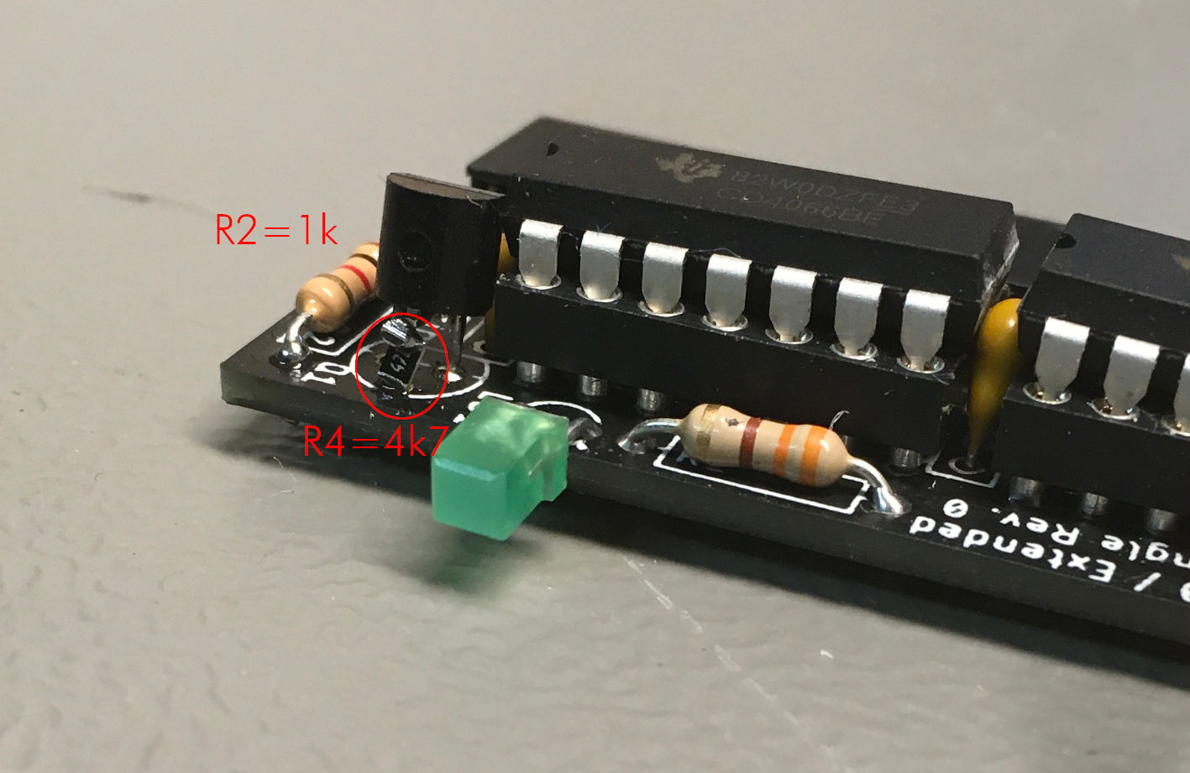

Figure 2: Modified Board Rev. 0

The modified Extended Keyboard Dongle was connected to a C64 (ASSY250469) instead of a Keyboard Dongle Rev. 0. The rest of the Diagnostic Harness was also connected to the C64. J2 (for the WRITE signal) was left open. The diagnostic Rev. 586220 test was running as usual, the keyboard and the control port were reported “OK”.

The WRITE signal was connected to J2. The test was repeated, both, the Control Ports and the Keyboard were reported “OK”.

IC2 was extracted from the socket (= four missing keyboard feedbacks). The test was repeated and the keyboard was reported “BAD”. IC2 was re-installed.

IC1 on the User Port Dongle was extracted from the socket (= four missing control port feedbacks). The test was repeated and the control ports were reported “BAD”.

WRITE was disconnected from the Extended Keyboard Dongle. The test was repeated and the Control Ports were reported “OK” (which is a false OK, because the feedbacks are missing). IC1 was reinstalled on the User Port Dongle. WRITE was connected to J2.

Finally, a 3 hours test run was performed, no problems were reported.

The modified Extended Keyboard Dongle is fully functional. A PCB revision is required.